978-774-8822
info@sunlinepatio.com
Checklist for Gas, Wood, Pellet Fireplace Insert
(Please circle one)

Name:______________________________________________________Phone:___________________
Address: ______________________________________________Email:__________________________
City:__________________________________State:__________Zip:______________________________
Is the inside of your fireplace Masonry?________Steel?________Is your chimney lined?____________
Is the exterior of your fireplace Stone?__________Brick? _________ Other?________

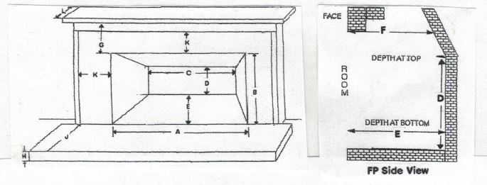

Fireplace opening: Width A__________________Height B _________________Arch?_____________
Fireplace back: Width C ___________________Height D (back flat part only)_____________________
Fireplace depth: E (bottom)___________F (top)___________G: Top of FP opening to mantle _________
Hearth: Height H_____Depth J_____Distance from edge of FP opening to trim K Top_____ Sides_____
Mantle: Depth L_____Mantle Trim Depth:______Depth of lintel (metal bar across top of opening)____
These measurements are important for us to properly fit your insert into your fireplace. Thank-you for
supplying us with this information.

Signed:_______________________________________________Date:____________________________

Please include pictures of current fireplace and chimney located outside your house.

